

Course No.: CSE 3202

Course Title: Artificial Intelligence & Machine Learing

Submitted to

Dr. Shohag Barman

Department of Computer Science and Engineering

Submitted by:

Meharab Hossen (212014025)Labib Hossain (212014019)

Sheikh Mostafa Asif Shafaat (212014029)

Md. Ayman Hasan (212014010)

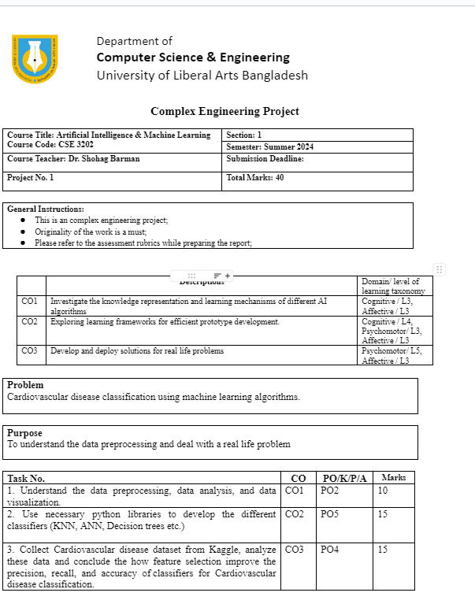

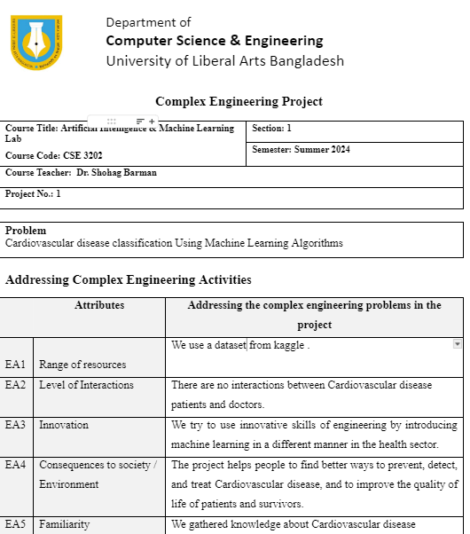

Problem

Develop a traditional Machine Learning/ Deep Learning based Artificial Intelligence (AI) system to classify and detect objects in real-world use cases.

Name

Breast cancer prediction and analysis using Machine Learning and Deep Learning.

Objective

This project aims to build and implement machine learning and deep learning models to predict and analyze breast cancer. By examining diverse datasets, the project wants to create accurate predictive models that can identify patterns and features indicating the risk of breast cancer.

Resources

The following methods and tools were used in this project:
• Google Scholar: utilized for searching study papers.
• Kaggle: Used for data collection.
• Google Colab: used to train machine learning models.
• Microsoft Word: utilized for recordkeeping and report generation.

Logic

The logics used in our project is described below-

Data Collection:

Data was collected from Kaggle in CSV format.

Data Analysis:

Loading the Dataset:

The dataset was loaded into a DataFrame using the pd.read_csv() function from the pandas library.

This allowed us to manipulate and explore the data using pandas' powerful datamanipulation capabilities.

Initial Exploration:

To gain a better understanding of the dataset, we performed an initial exploration using functions such as head(), info(), and describe().

The head() function displayed the first few rows of the dataset, providing a glimpse of the data's structure and the columns it contains.

The info() function provided an overview of the data types, non-null counts, and memory usage, helping us identify any potential data type inconsistencies or missing values.

The describe() function offered summary statistics for numerical columns, including mean, standard deviation, minimum, maximum, and quartiles. This helped us assess the distribution and range of each feature.

Handling Missing Values:

Data quality is essential for accurate analysis and model training. We used the is null().sum() function to check for missing values in the dataset.

Ensuring that no missing values were present in critical columns was essential, as these values could negatively impact the performance of machine learning algorithms.

If missing values were found, appropriate strategies such as imputation or removal of rows with missing values would be applied to maintain data integrity.

Class Distribution:

Understanding the distribution of classes in a classification problem is crucial, as class imbalance can affect model performance.

In this project, we examined the distribution of benign (0) and malignant (1) cases using visualization techniques.

Bar plots and counts were used to visualize and quantify the balance between the two classes. This analysis provided insights into potential class imbalance issues.

Classifier Selection:

Part of data analysis involves considering suitable machine learning algorithms for the task at hand.

In this project, we opted to implement the following classifiers: KNN, SVM, ANN and logistic regression.

The decision to use these classifiers was influenced by their simplicity, interpretability, and proven performance in similar classification tasks.

Feature Visualization:

While not explicitly mentioned in the data analysis section, visualizing the distribution of features using histograms allowed us to understand the spread and potential discriminative power of individual features.

Histograms provided insights into whether the features have distinct distributions for different classes, which can impact the performance of machine learning algorithms.

Data Visualization:

The Matplotlib and Seaborn libraries were used for data visualization.

Histograms were created to visualize the distribution of various columns, providing insights into data characteristics.

Bar plots and scatter plots were generated to visualize the distribution of benign and malignant cases.

Data Preprocessing:

The dataset was preprocessed by converting categorical values into numerical ones for algorithm compatibility.

The dataset was split into training and testing sets using train_test_split() from scikit-learn.

Feature scaling was performed using StandardScaler() to standardize the feature values.

Logistic regression:

We instantiated a logistic regression model using LogisticRegression() from scikit-learn.

The model was trained using the training data with the fit() method.

Predictions were made on the test data using the predict() method.

We calculated the accuracy of the model's predictions using accuracy_score() from scikit-learn.

To further evaluate the model's performance, we generated a classification report using classification_report().

K Nearest Neighbors (KNN) Algorithm:

An instance of KNeighborsClassifier() was created from scikit-learn.

The model was trained using the training data.

Predictions were made on the test data using predict() and accuracy was calculated using accuracy_score().

Classification report was generated using classification_report() to evaluate model performance.

Artificial Neural Network (ANN) Algorithm:

Set initial values for weights and biases randomly or using predefined values.

Pass input through the network, and calculate predictions using activation functions.

Compute gradients of loss function, update weights and biases using optimization techniques.

Iterate over the dataset, adjusting parameters to minimize loss.

Assess model's performance on unseen data to ensure generalization.

Deploy a trained model for real-world predictions on new data.

Support Vector Machine (SVM) Algorithm:

An instance of SVC() from scikit-learn was created to initialize the Support Vector Machine classifier.

The SVM model was trained using the fit() method with the training data.

Predictions were made on the test data using the predict() method.

Model accuracy was calculated using accuracy_score() from scikit-learn.

Additional evaluation metrics, such as precision, recall, and F1-score were calculated using classification_report().

Random Forest Algorithm:

Initialize a Random Forest classifier using RandomForestClassifier() from scikit-learn.

Train the Random Forest model using the fit() method with the training data.

Predict class labels for the test data using the predict() method.

Evaluate the model's accuracy using accuracy_score() from scikit-learn.

Optionally, analyze feature importance using feature_importances_ attribute of the trained model.

Keras :

Define the architecture of the neural network model using the Keras Sequential or Functional API.

Compile the model by specifying the optimizer, loss function, and evaluation metrics.

Train the model on training data using the fit() method, specifying batch size, number of epochs, and optional validation data.

Optionally, visualize training history using plot() or plot_loss() to monitor training and validation metrics.

Evaluate the trained model's performance on test data using the evaluate() method to calculate loss and metrics.

Make predictions on new data using the predict() method.

Input

Code snippets of our program are attached below-

Import necessasry libraries and data in collab

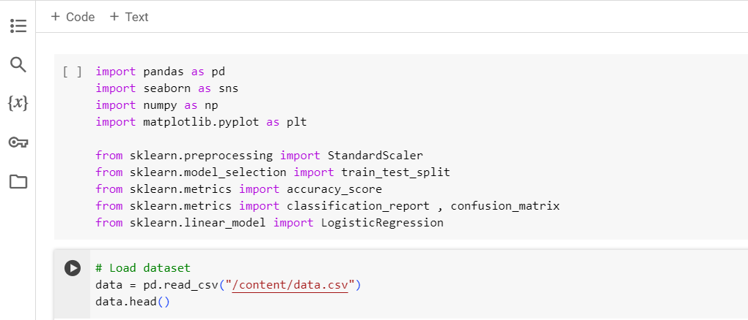

Getting information about the data

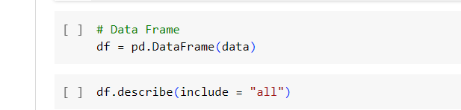

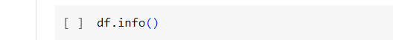

To check if any data is missing

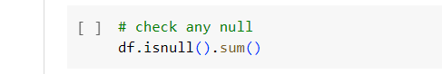

check for any duplicate row,if present then drop it

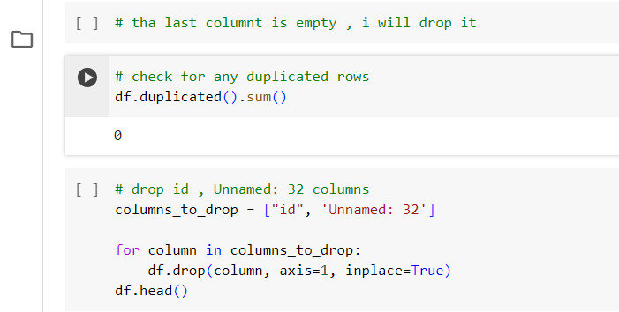

visualize the data

coverting the data into numeric value

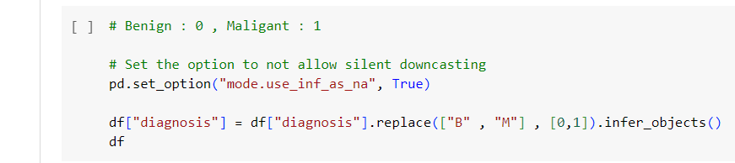

Feature list set up

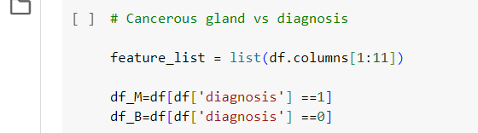

Feature list set up

conversion and mean value calculation

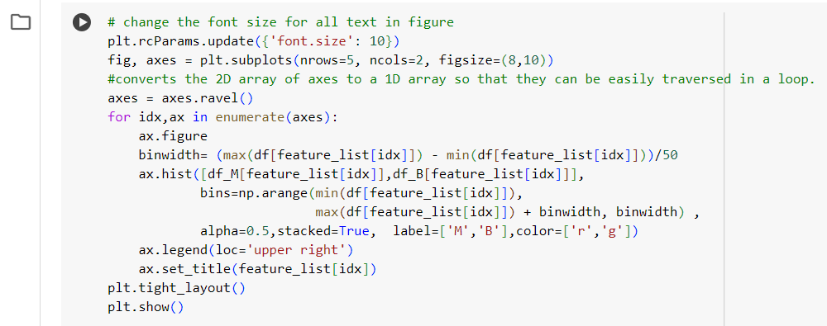

Correalation map

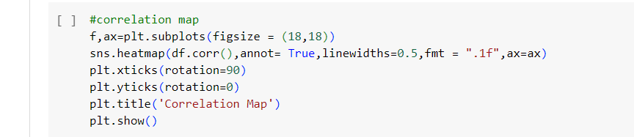

Logistic Regression

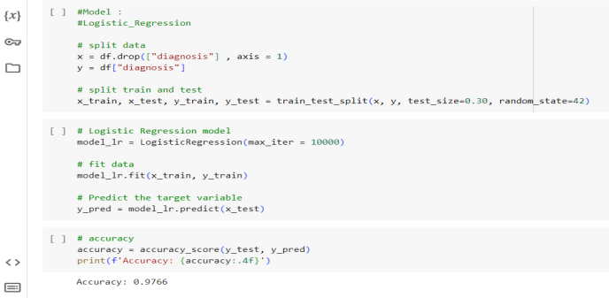

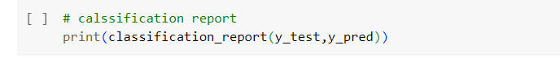

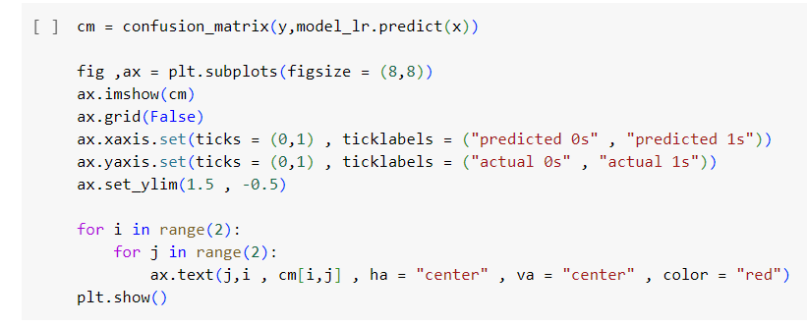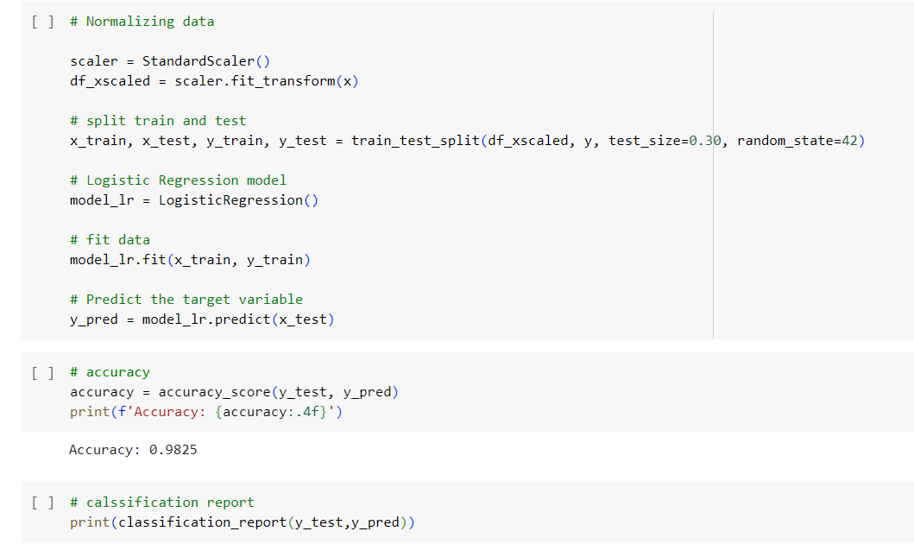

K Nearest Neighbors (KNN)

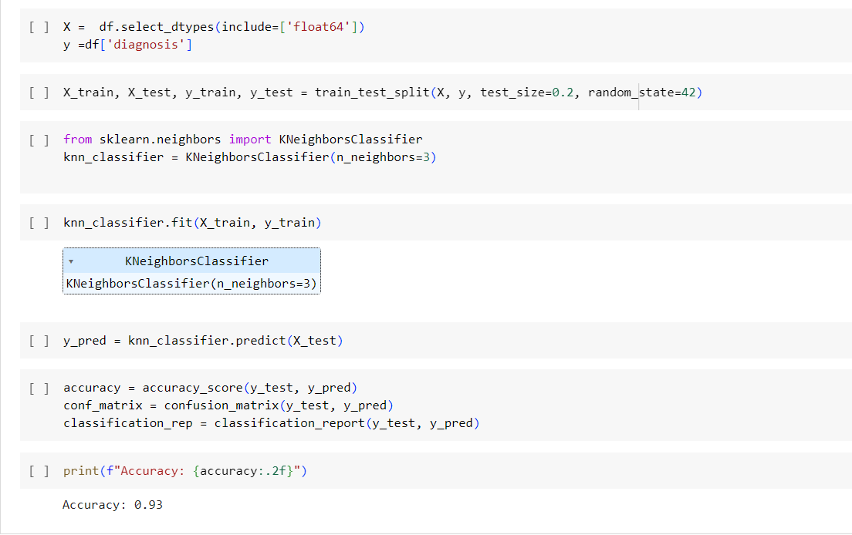

Artificial Neural Network (ANN)

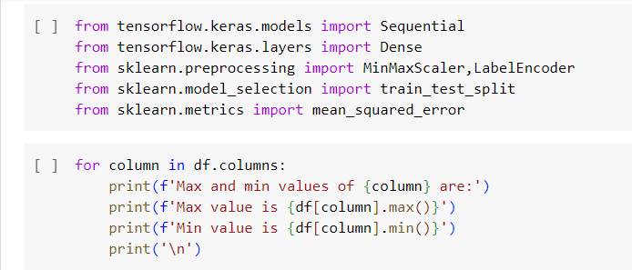

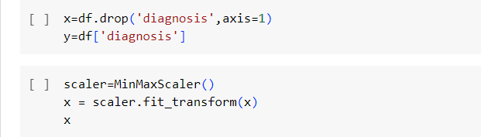

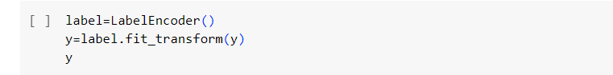

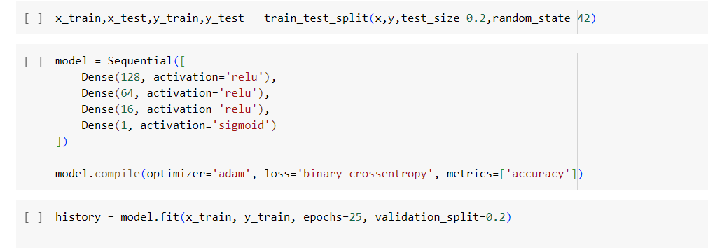

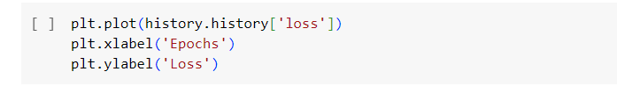

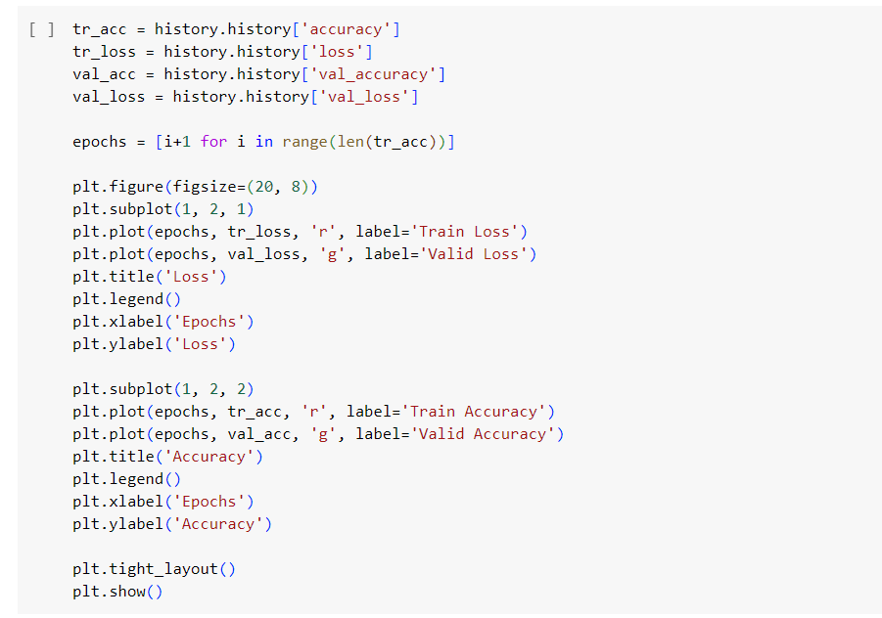

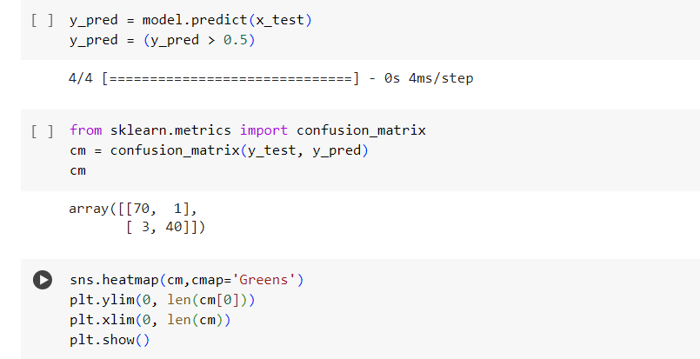

Exploratory Data Analysis

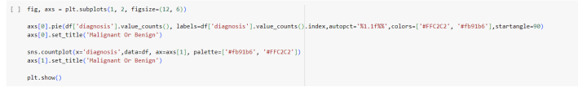

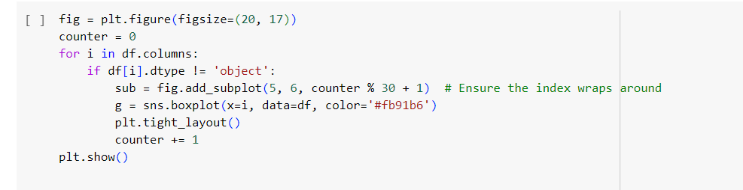

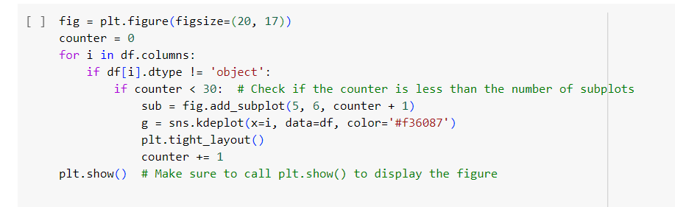

Support Vector Machine (SVM)

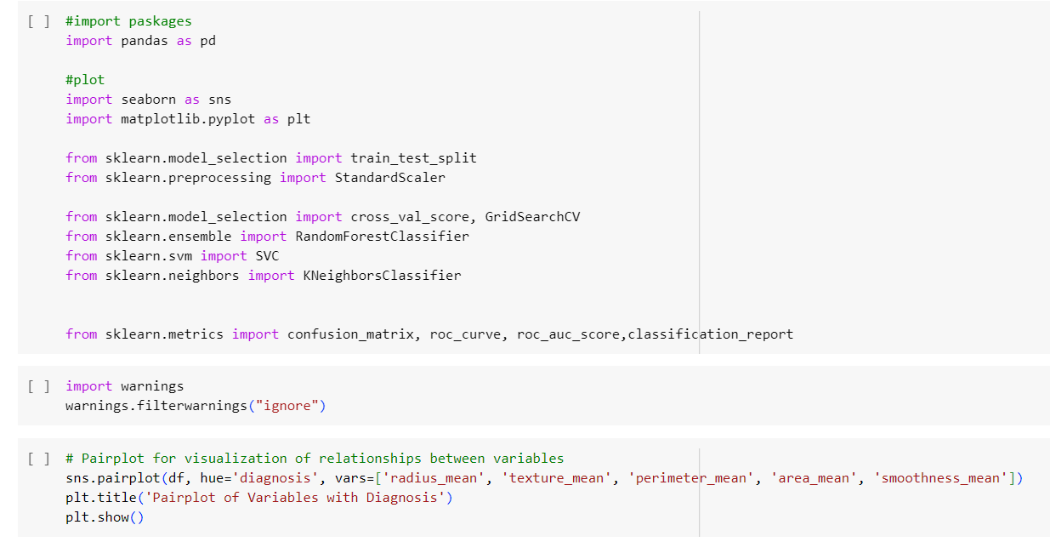

diagnosis distribution

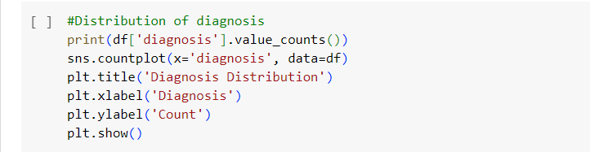

Comparing the diagnosis via boxplot

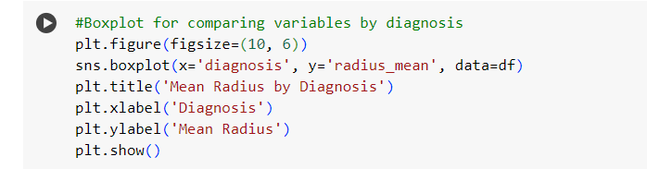

Comparing the diagnosis via Violin plot

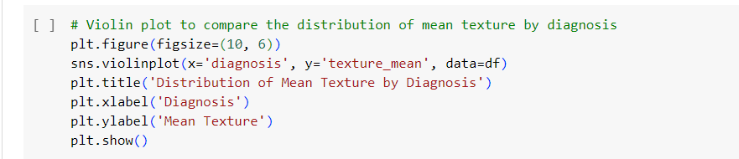

Comparing the diagnosis via swarm plot

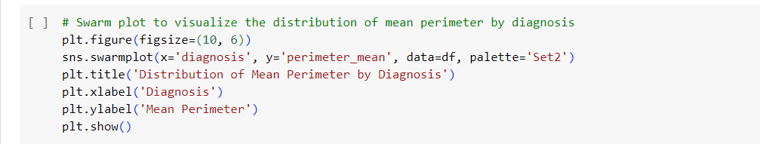

Processing the dataset

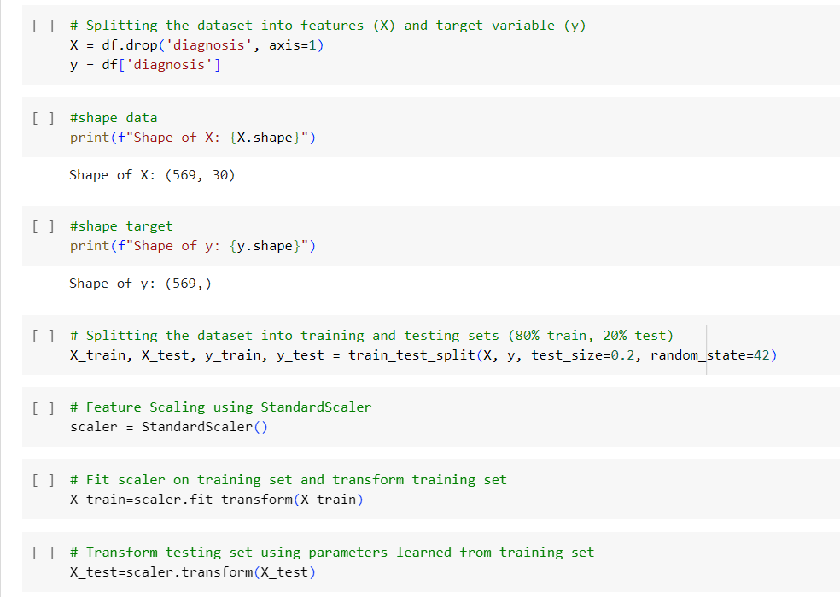

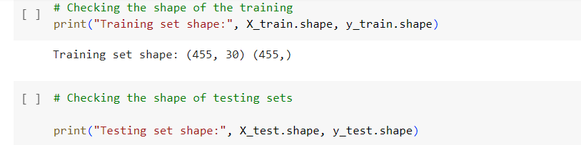

Random Forest

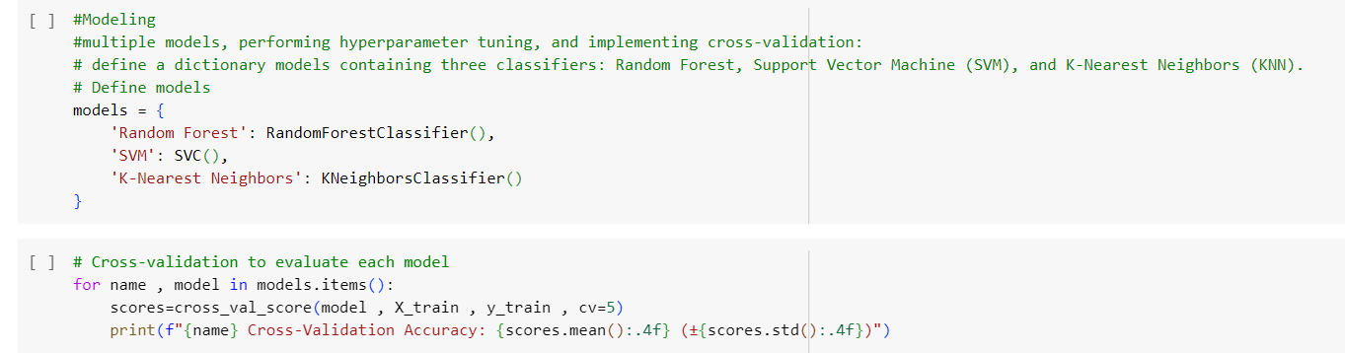

Data processing and cross validation

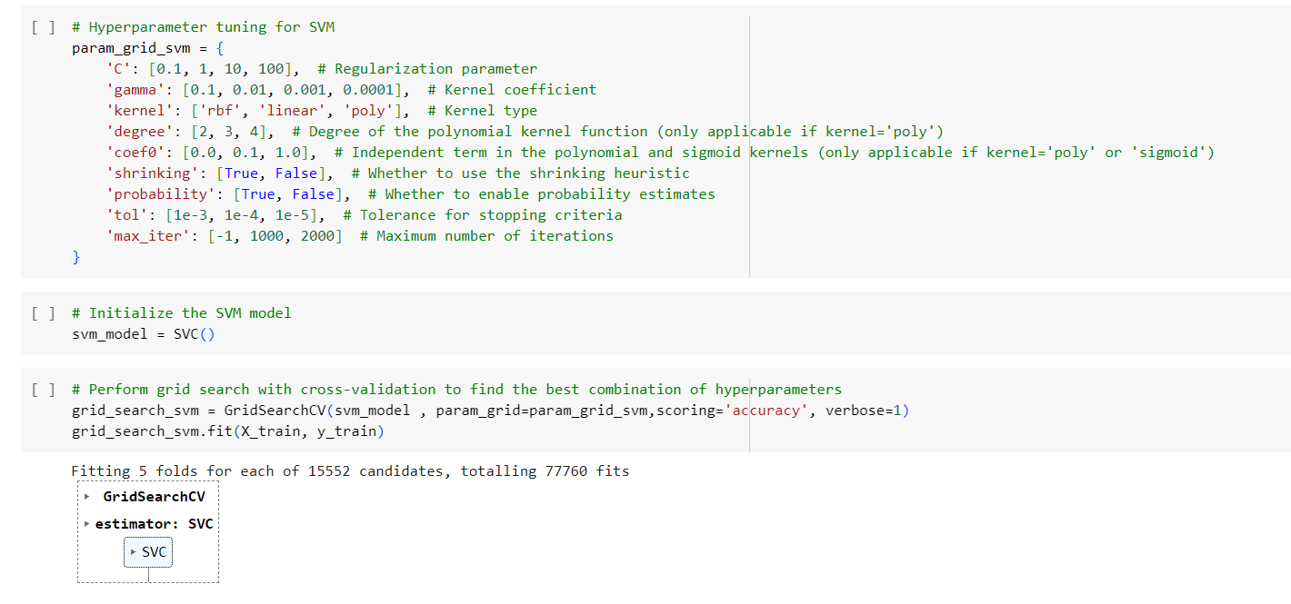

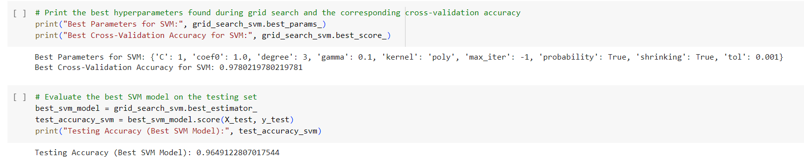

Confusion matrix plot

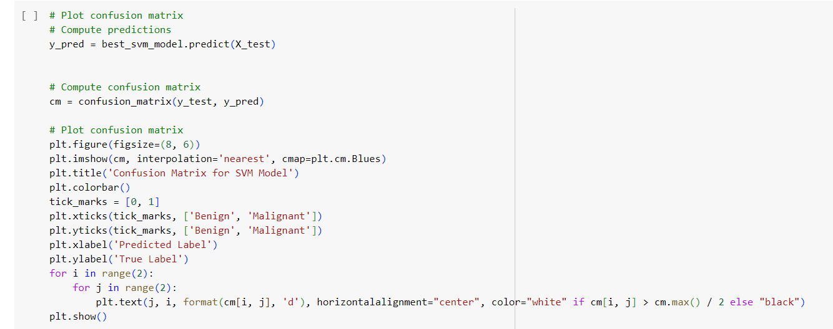

Classification report

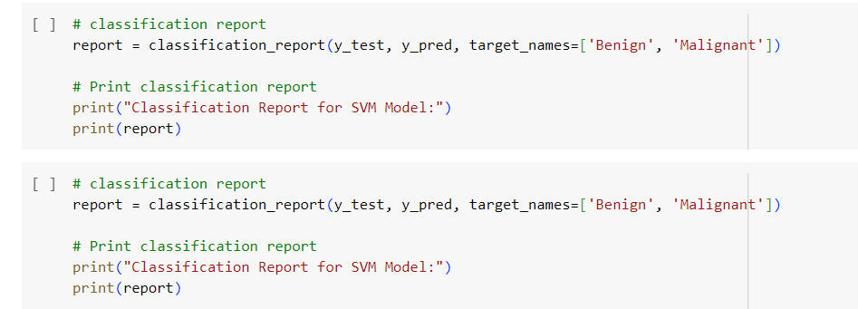

Keras

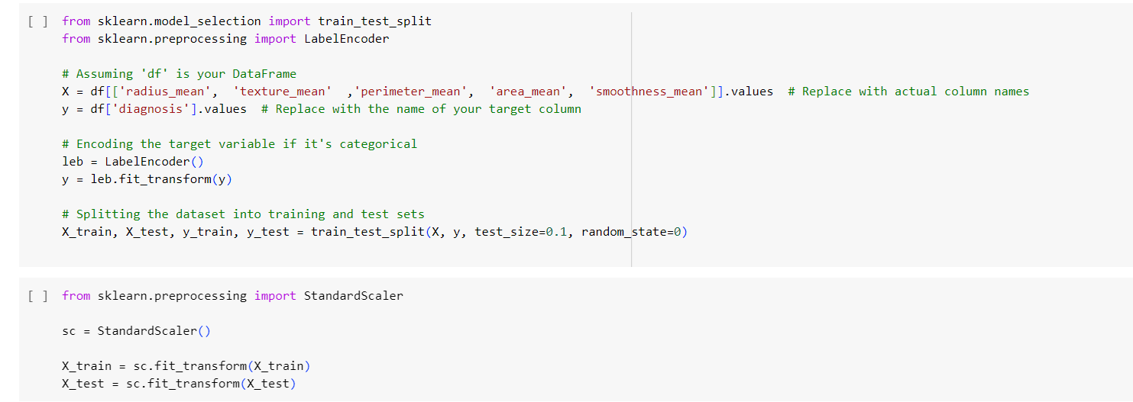

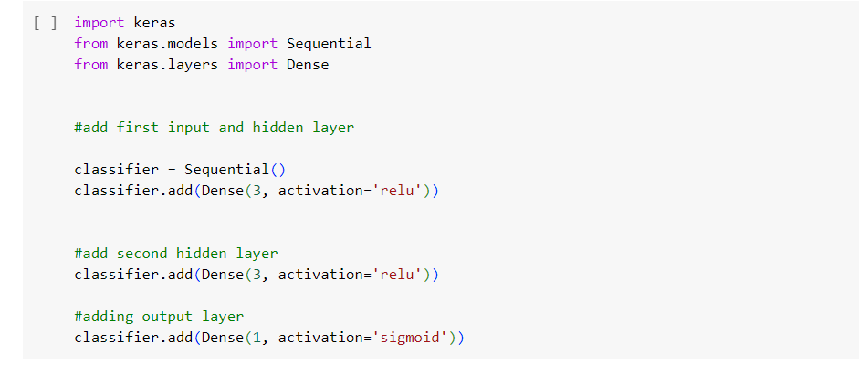

Classifier and data train

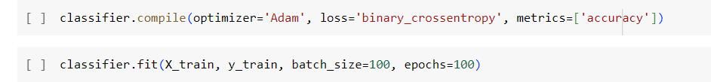

Prediction

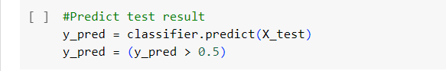

Confusion metric

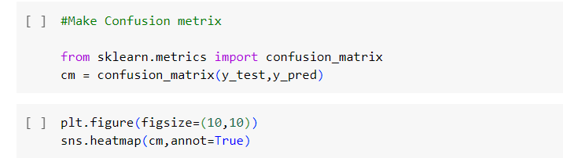

Output

The output from each code section is given below-

Data after loading in the colab. There are more Column available but the screenshot is not able to fit it.

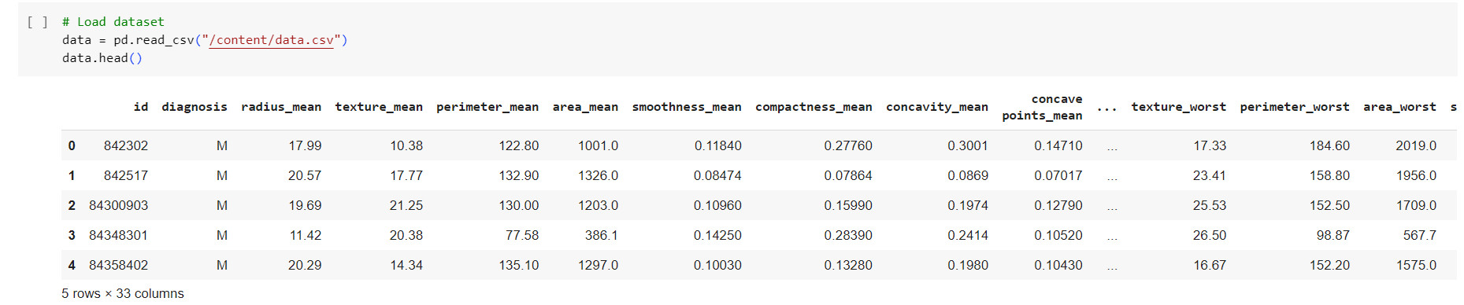

Overall data information

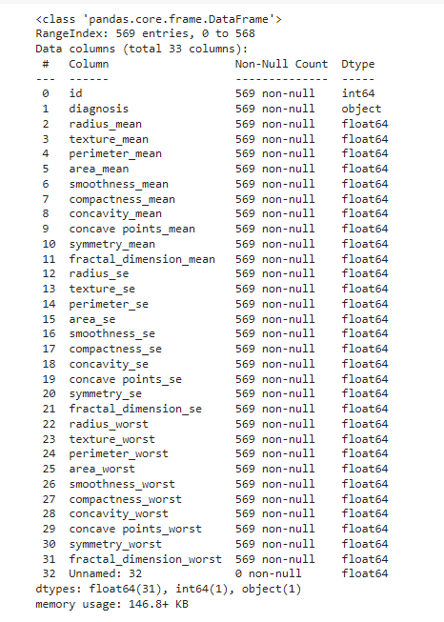

Checking for null value

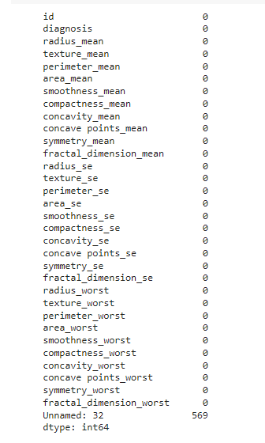

Dataset after diagnosis distribution

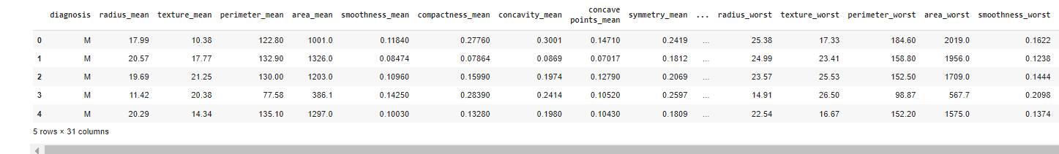

Bar chart; Visual Representation for Benign (0) and Malignant (1)

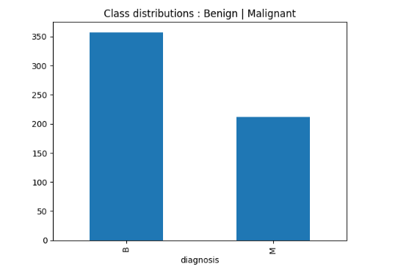

Dataset after diagnosis distribution and numeric conversion

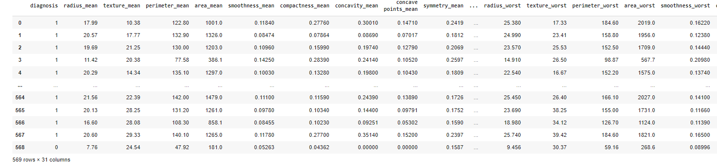

Mean calculation

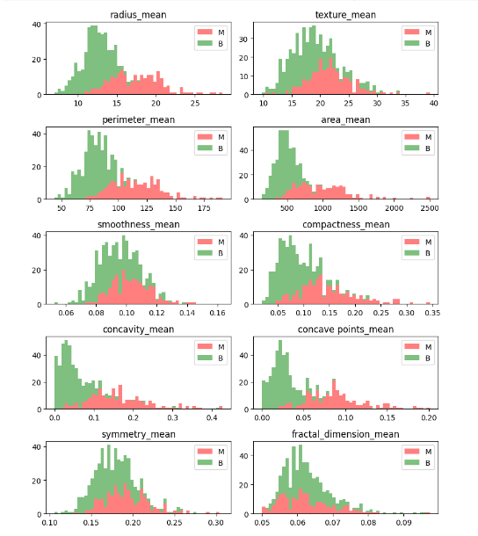

Correlation map

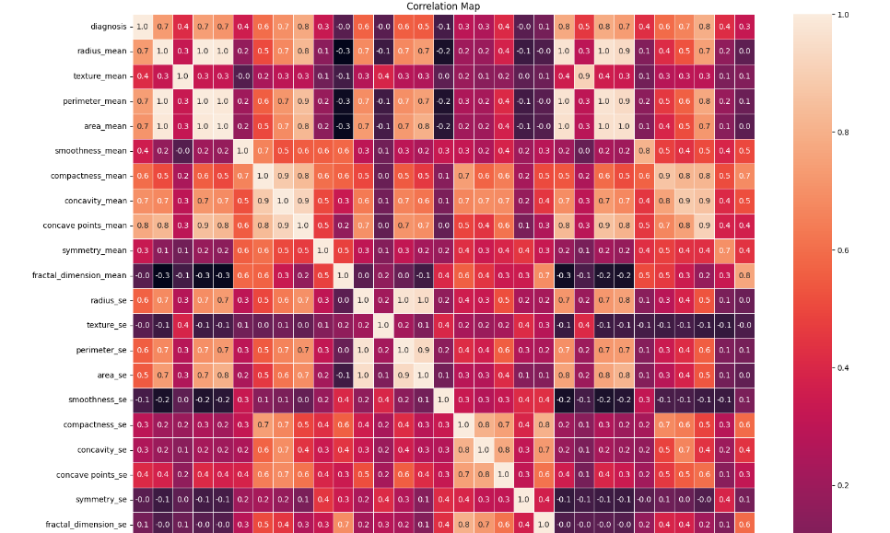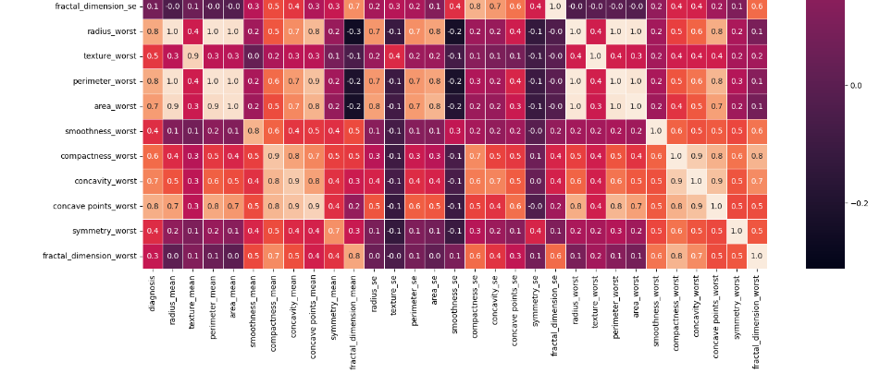

Logistic regression classification report

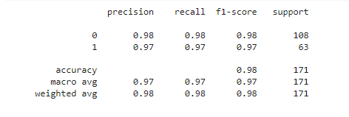

Confusion matrix

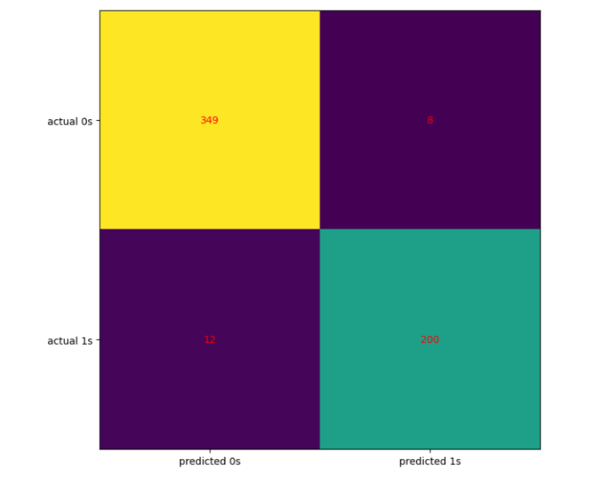

KNN

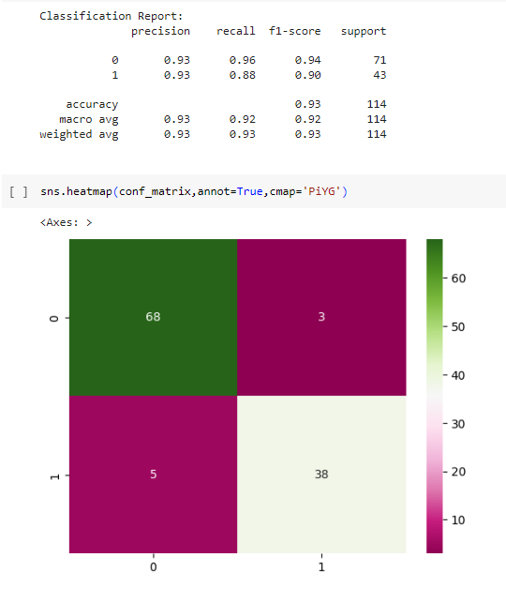

ANN (min max value)

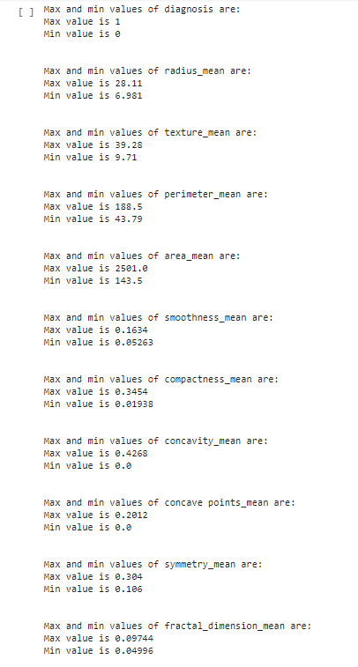

Min-max scaler

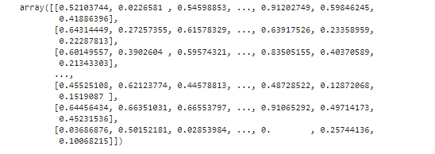

Array

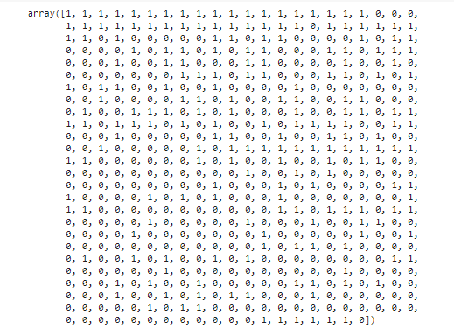

History(epoch)

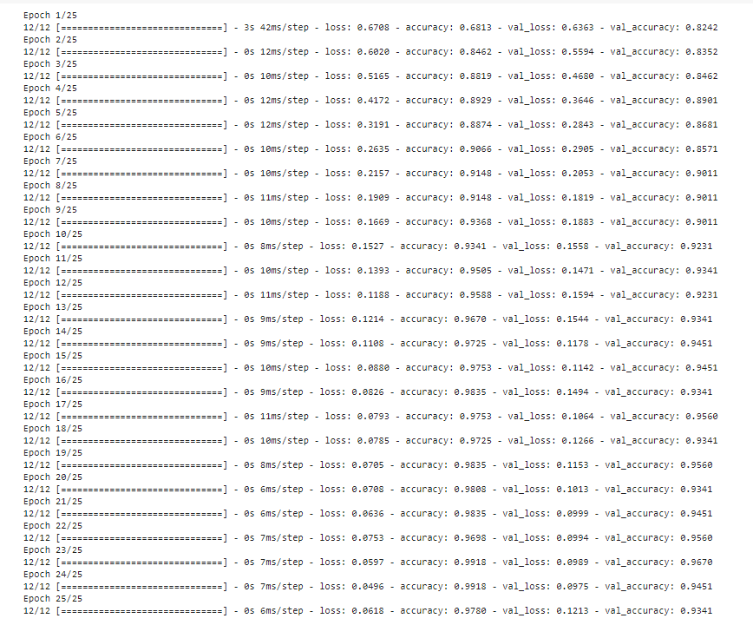

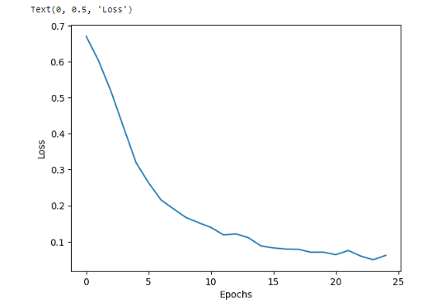

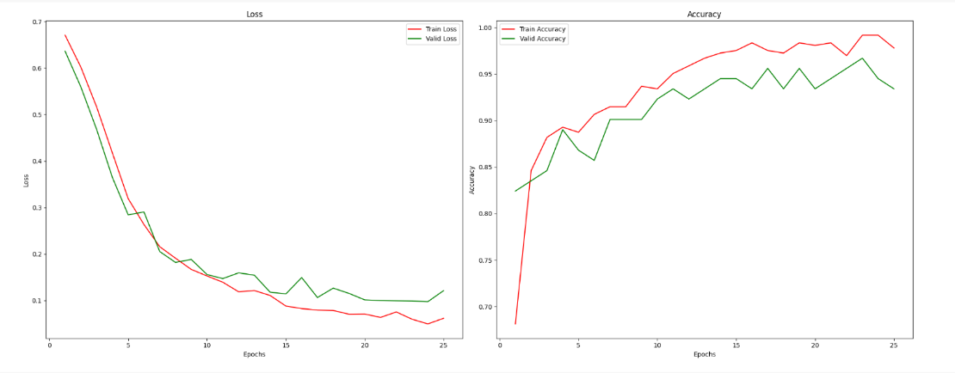

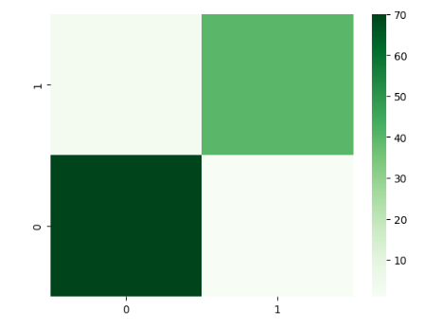

EDA

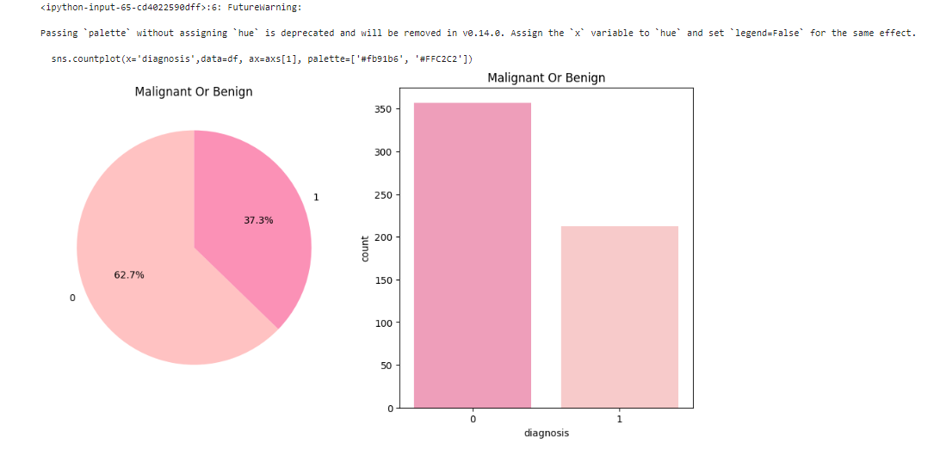

Pit figures

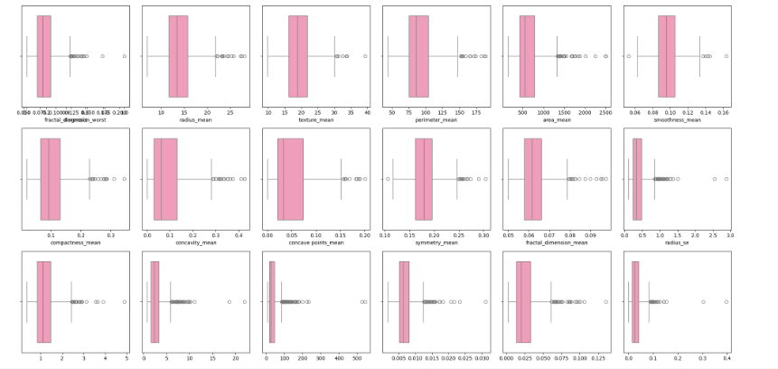

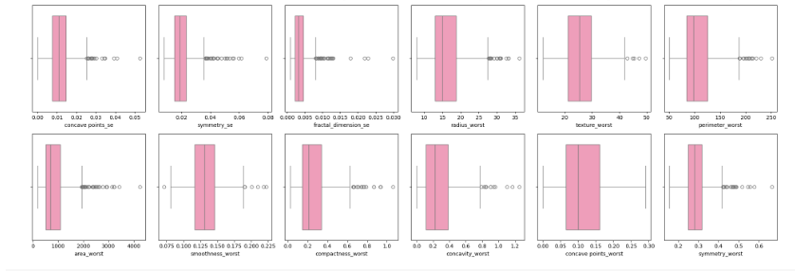

Histograms

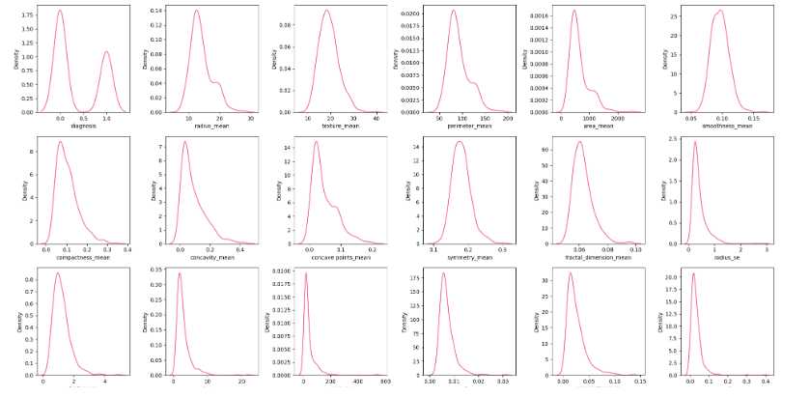

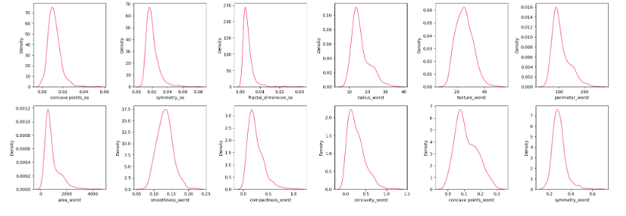

SVM (pair plot)

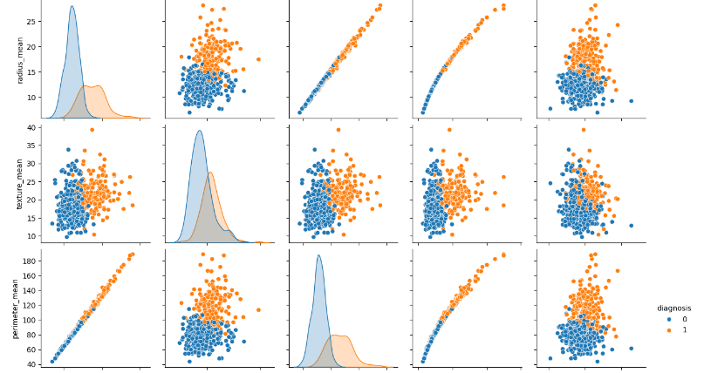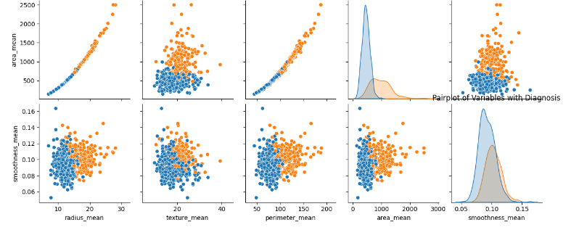

Diagnosis distribution, Visual Representation for Benign (0) and Malignant (1)

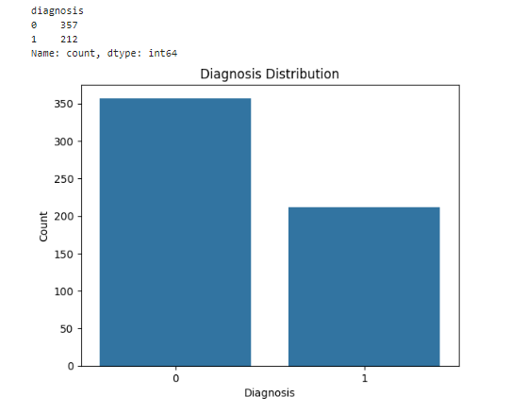

Box plot

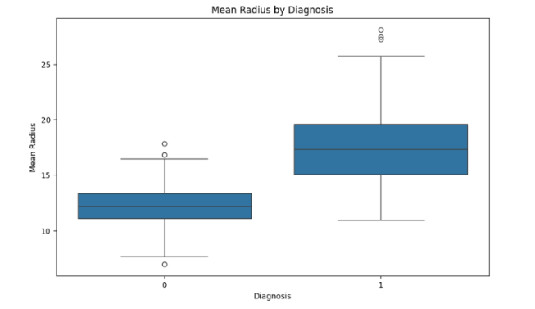

Violin plot

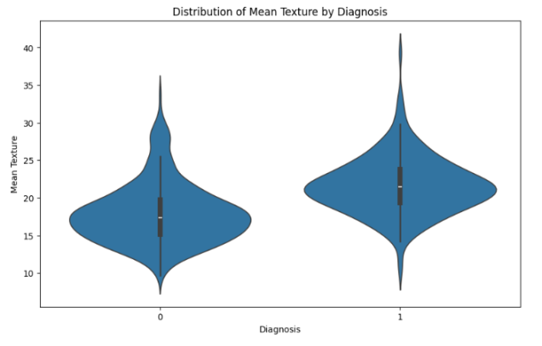

swarm plot

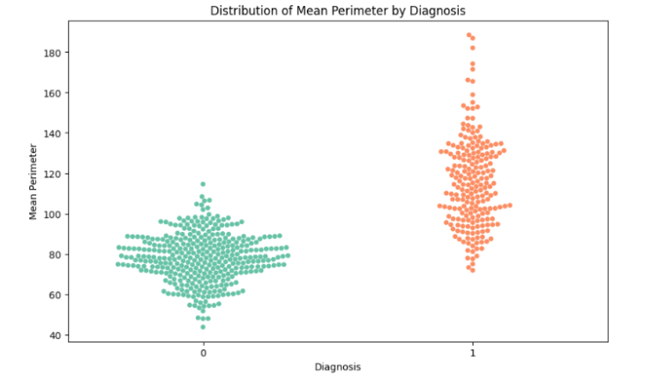

Confusion matrix for SVM

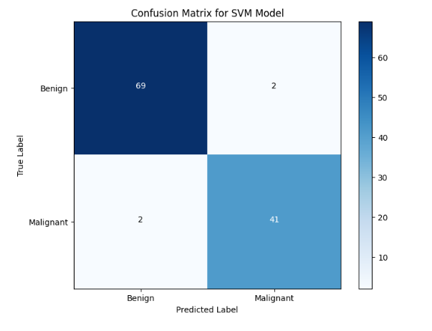

Classification report for SVM

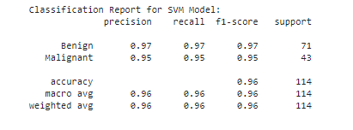

Epoch loss and accuracy (the list longer but could not fit here that is why only a snippet is given here)

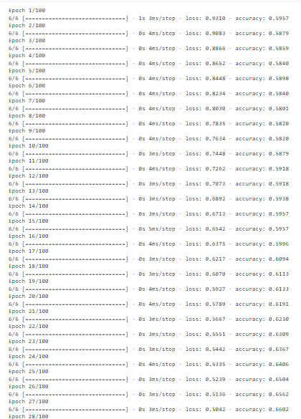

Final confusion matrix

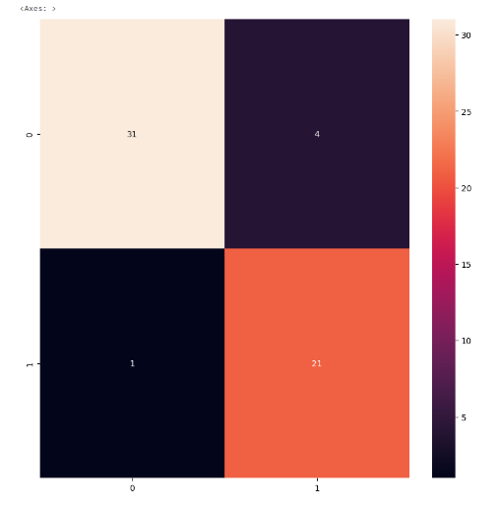

Conclusion:

The application of machine learning and deep learning methods in breast cancer prediction and analysis holds significant promise for improving diagnostic accuracy and patient outcomes. By leveraging diverse data sources and employing robust preprocessing, exploratory analysis, and model selection strategies, healthcare workers can create effective predictive models. The integration of advanced algorithms, such as CNNs for imaging data and ensemble methods for structured data, improves the ability to spot patterns indicative of breast cancer. Continuous evaluation and hyper parameter tuning further refine these models, paving the way for personalized treatment approaches and early detection, ultimately adding to better healthcare solutions.

